

**Continuing**

**Education**

**Program**

**Center for Computing and Information Technology**

**Faculty of EngineeringUniversity of Indonesia**

**PROJECT ON**

**“E-books Prog Web Based Application”**

**Group : 10**

**Jasmine Nabila Novel**

**Yansiska**

**­­**

**Faculty : Riza Muhammad Nurman S.Kom**

**Class : 4 SC 4**

Faculty of Engineering University of Indonesia

Depok 16424

2017

**PROJECT ON**

*E-books Prog Web Based Application*

Developed By

*Name : Jasmine Nabila Novel*

*Yansiska*

NIIT

**E-books Prog Web Based Application**

Batch Code : 4 SC 4

Start Date : April 11th, 2018

End Date : April 20th, 2018

Name Of The Coordinator : Riza Muhammad Nurman S.Kom

Name Of Developer : Jasmine Nabila Novel

Yansiska

Date Of Submission : April 20th, 2018

NIIT

**CERTIFICATE**

This is to certify that this report, titled Activity Diagram For E-Books Prog Web Based Application embodies the original work done by ***Jasmine Nabila Novel and Yansiska*** in partial fulfillment of their course requirement at NIIT.

Coordinator:

*Riza Muhammad Nurman S.Kom*

**ACKNOWLEDGEMENT**

We have benefited a lot from the feedback and suggestions given to us by Mr. Riza Muhammad Nurman S.Kom and other faculty members. The Project presentation opportunity we have with CCIT-FTUI is a greatchance for learning and professional development. Therefore, we consider ourselves very lucky as we are provided with an opportunity to be a part of it. We are also grateful for having a change to meet so many wonderful people and professionals who led us through this project period.

Bearing in mind, we would like to express our deepest gratitude and special thanks to Riza Muhammad Nurman S.Kom of CCIT-FTUI faculty who is spite of being extraordinarily busy with her duties, took time out to hear, guide and keep us on the correct path and allowing us to carry out our project until completion.

Our Project assignment won’t be as good as it is now without any help, feedback and suggestion that were given to us by our friends within the campus. So, we would also like to say thank you to all of them. We will strive to use gained skills and knowledge in the best possible way, and we will continue to work on the improvements, in order to attain desired career objective.

**SYSTEM ANALYSIS**

**System Summary:**

The proposed software system for E-books Prog Web Based Application will be used by two different types of user:

1. Admin
2. User

The proposed software system needs to provide the following functionalities to the Admin of Rent House:

1. Allow to Add Modify, Delete Other Admin.
2. Allow to Add Modify Delete Ebooks.

The proposed software system also provide the following functionality to the User of Ebooks Online :

1. View List Ebook
2. Read Online Ebooks or Download

**HARDWARE AND SOFTWARE REQUIREMENTS**

**Hardware: Acer Aspire ES14, AMD A4 8.00 GB (RAM)**

**Operating System: Microsoft Windows 10. , 64-bit Operating System**

**Software: Astah Jude Professional**

**SQL Server 2008**

**Netbeans IDE 8.0.2**

**INDIVIDUAL PROJECT SCHEDULE**

|  |  |  |  |  |  |
| --- | --- | --- | --- | --- | --- |
| **S. No** | **Activity Description** | **Planned Date of Completion** | **Actual Date** | **Responsibility** | **Remarks** |
| 1 | Creating the UML Diagrams | 19th April 2018 | 19th April 2018 | Jasmine and Yansiska |  |
| 2 | Creating the Admin Page | 11th April 2018 | 12th April 2018 | Jasmine and Yansiska |  |
| 3 | Creating Login Page | 13th April 2018 | 13th April 2018 | Jasmine and Yansiska |  |
| 4 | Creating User Page | 14th April 2018 | 15th April 2018 | Jasmine and Yansiska |  |

**ACTIVITY DIAGRAM FOR E-BOOKS PROG WEB BASED APPLICATION**

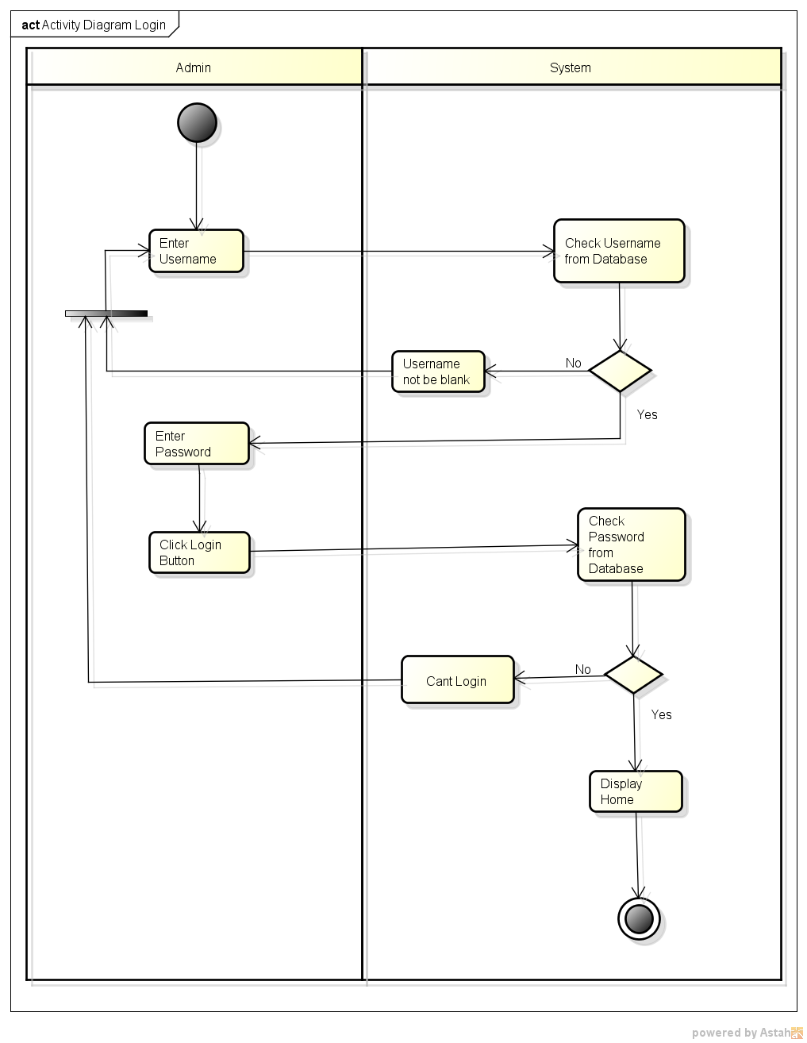

*Activity Diagram Login*

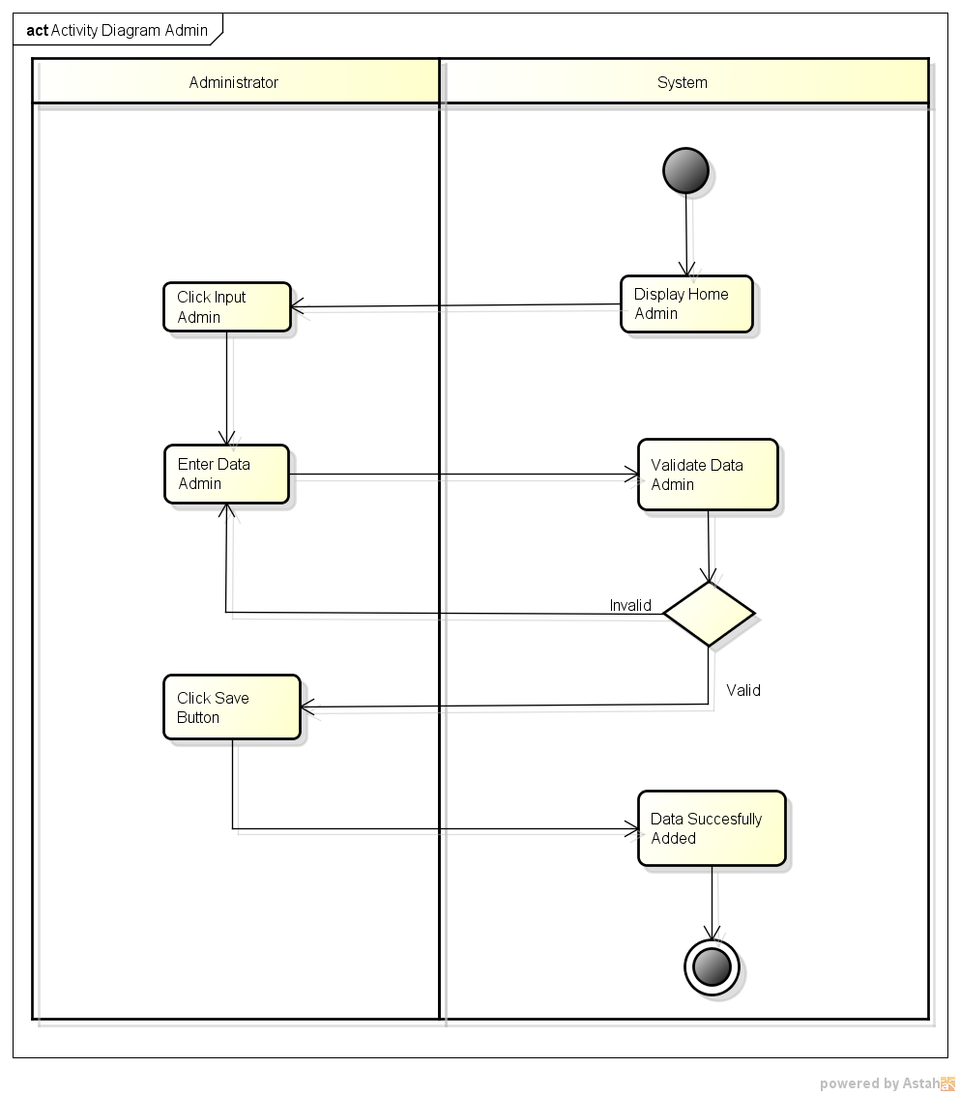

*Activity Diagram Add Admin*

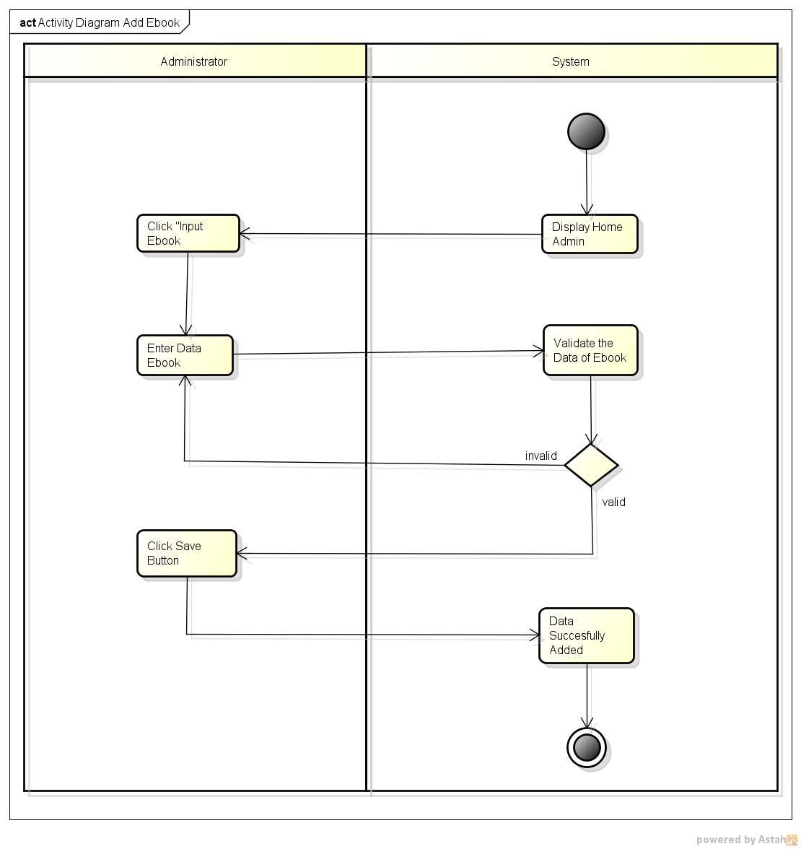

*Activity Diagram Add Ebook*

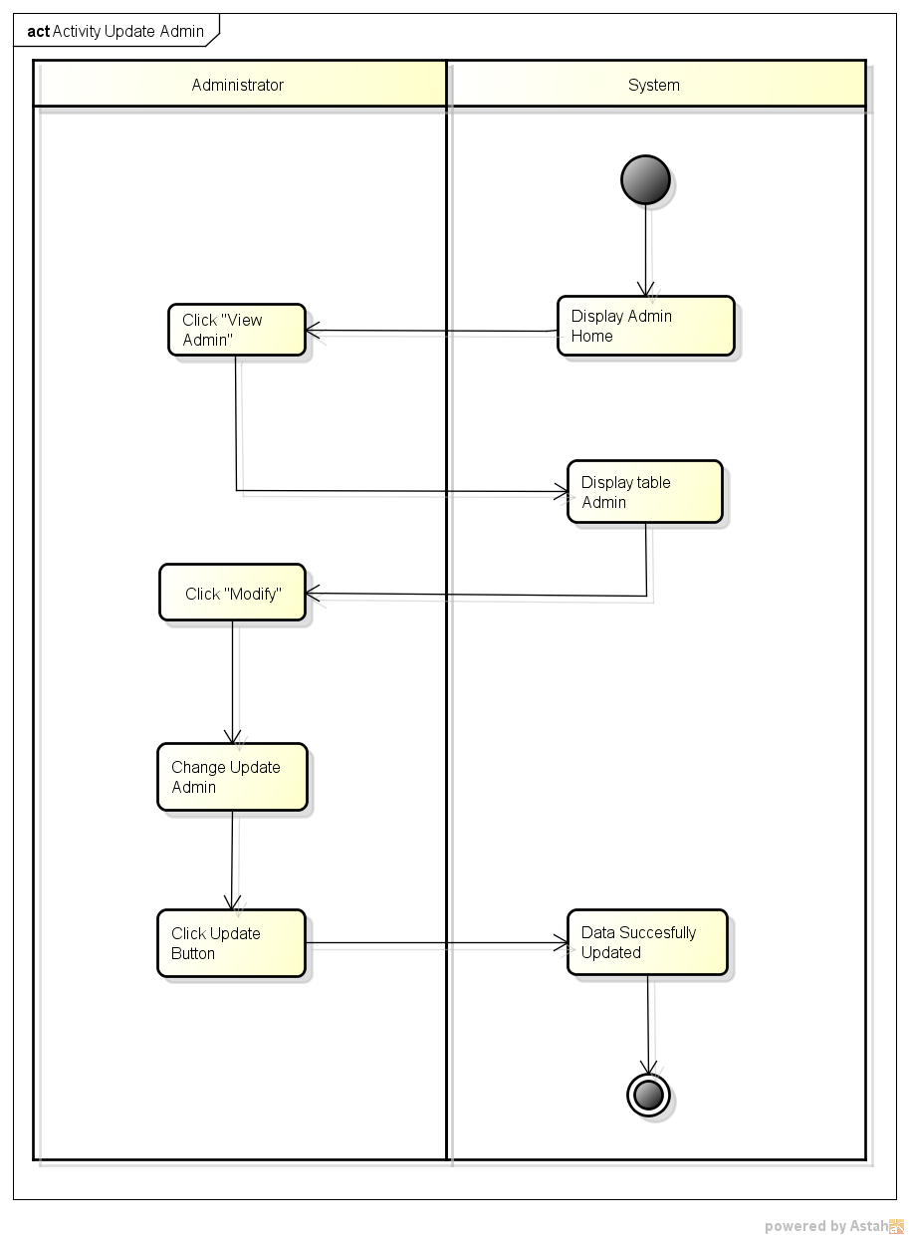

*Activity Diagram Update Admin*

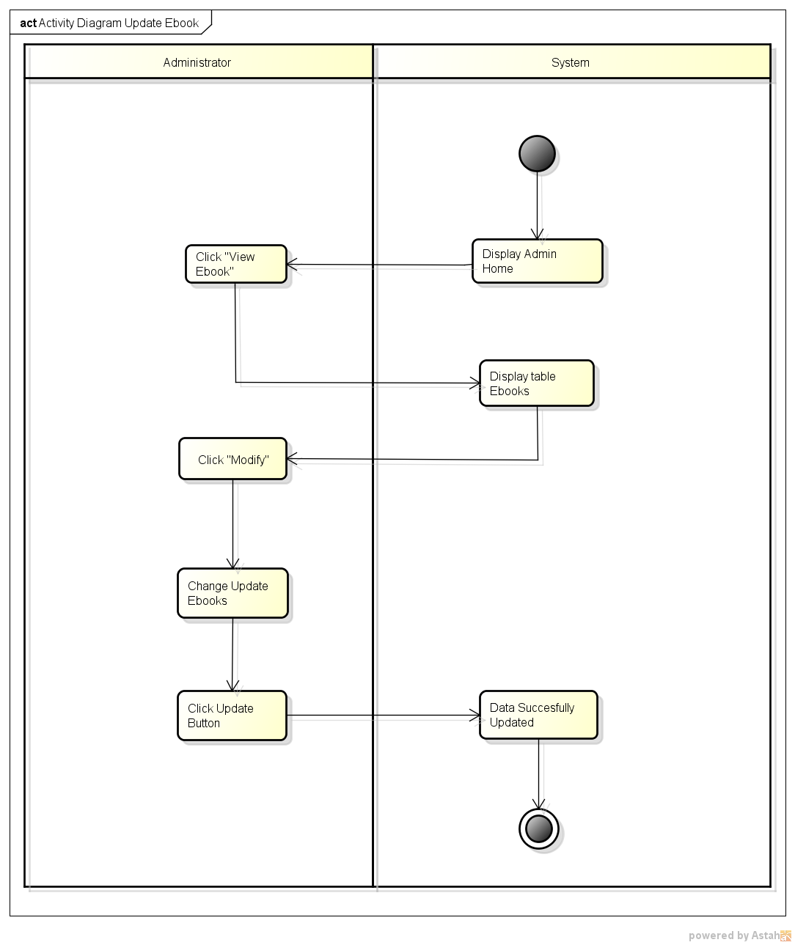

*Activity Diagram Update Ebooks*

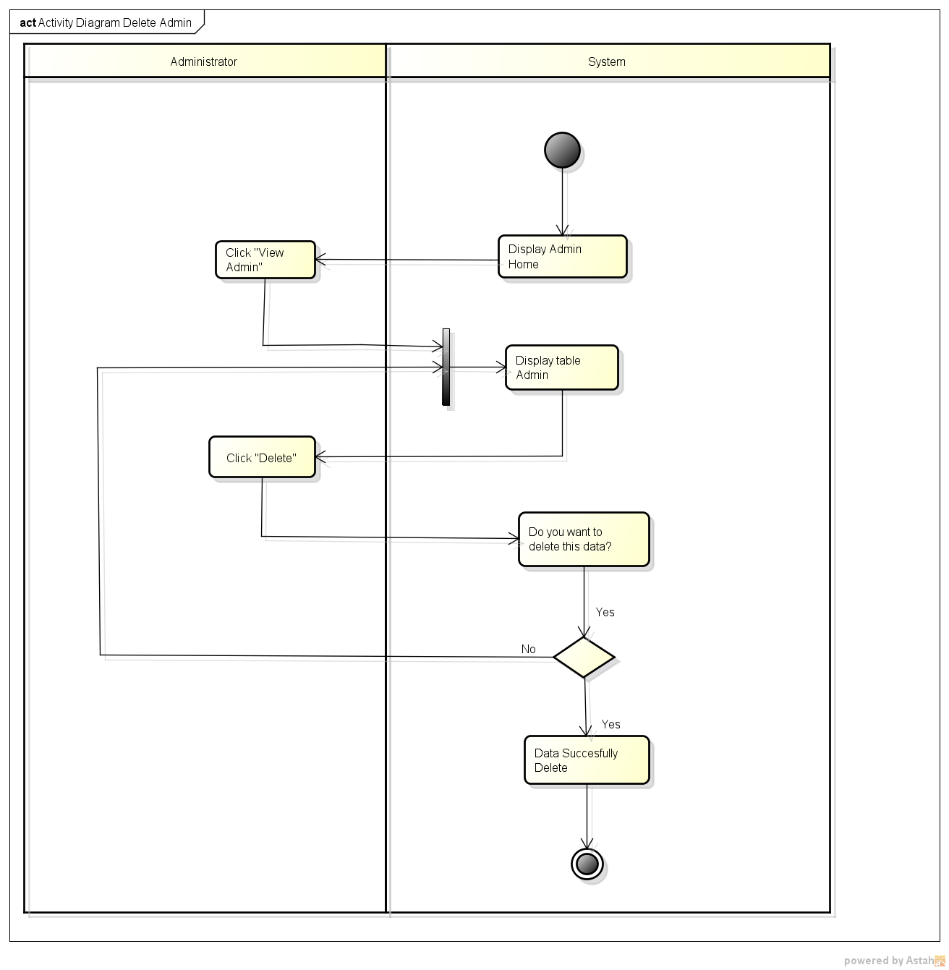

*Activity Diagram Delete Admin*

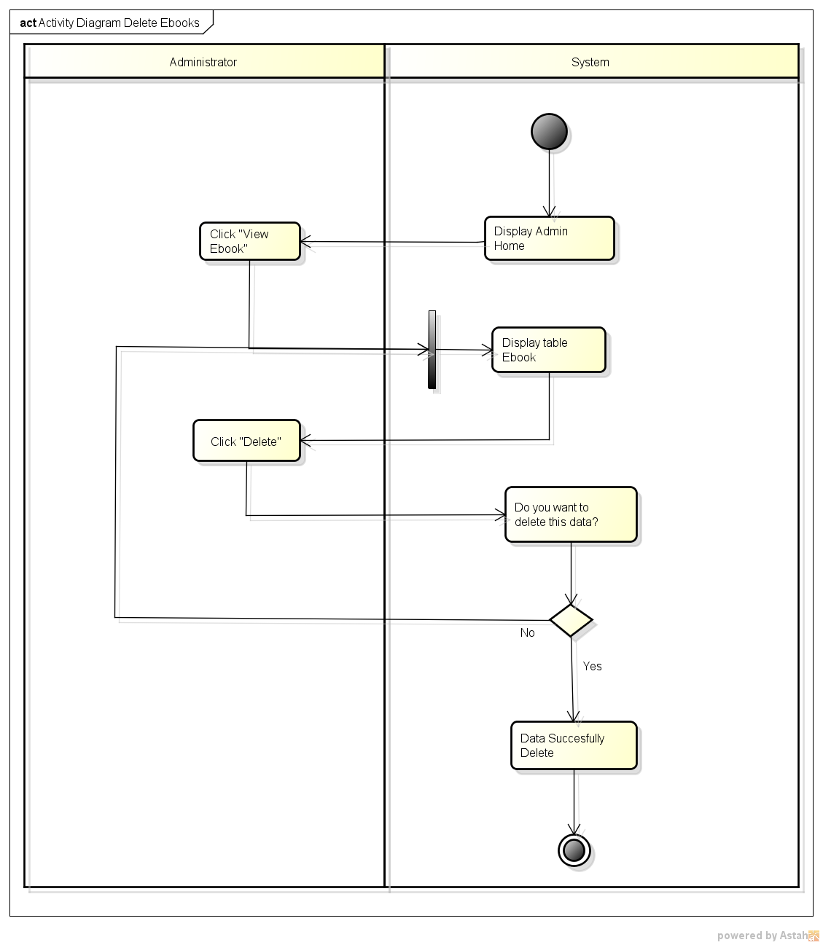

*Activity Diagram Delete Ebooks*

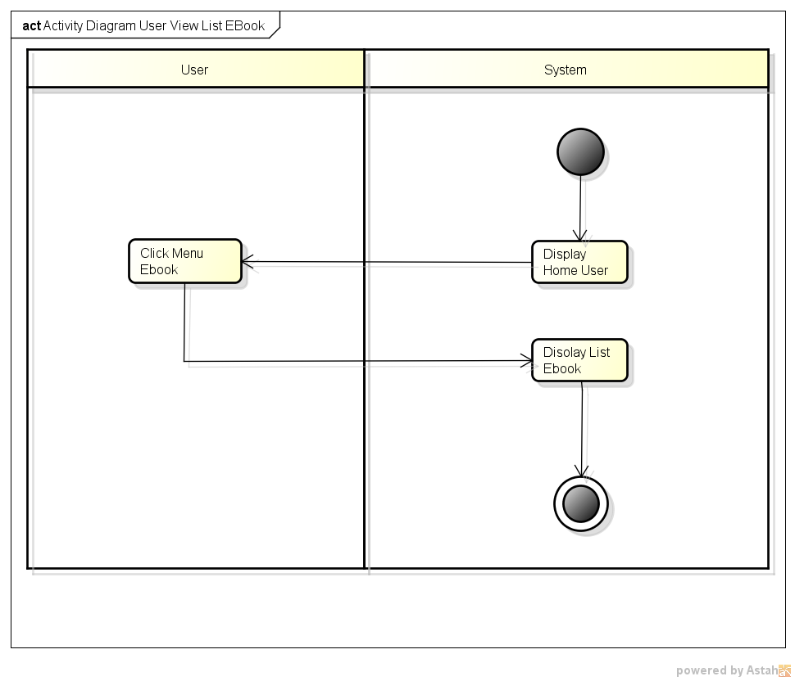

*Activity User View List Ebooks*

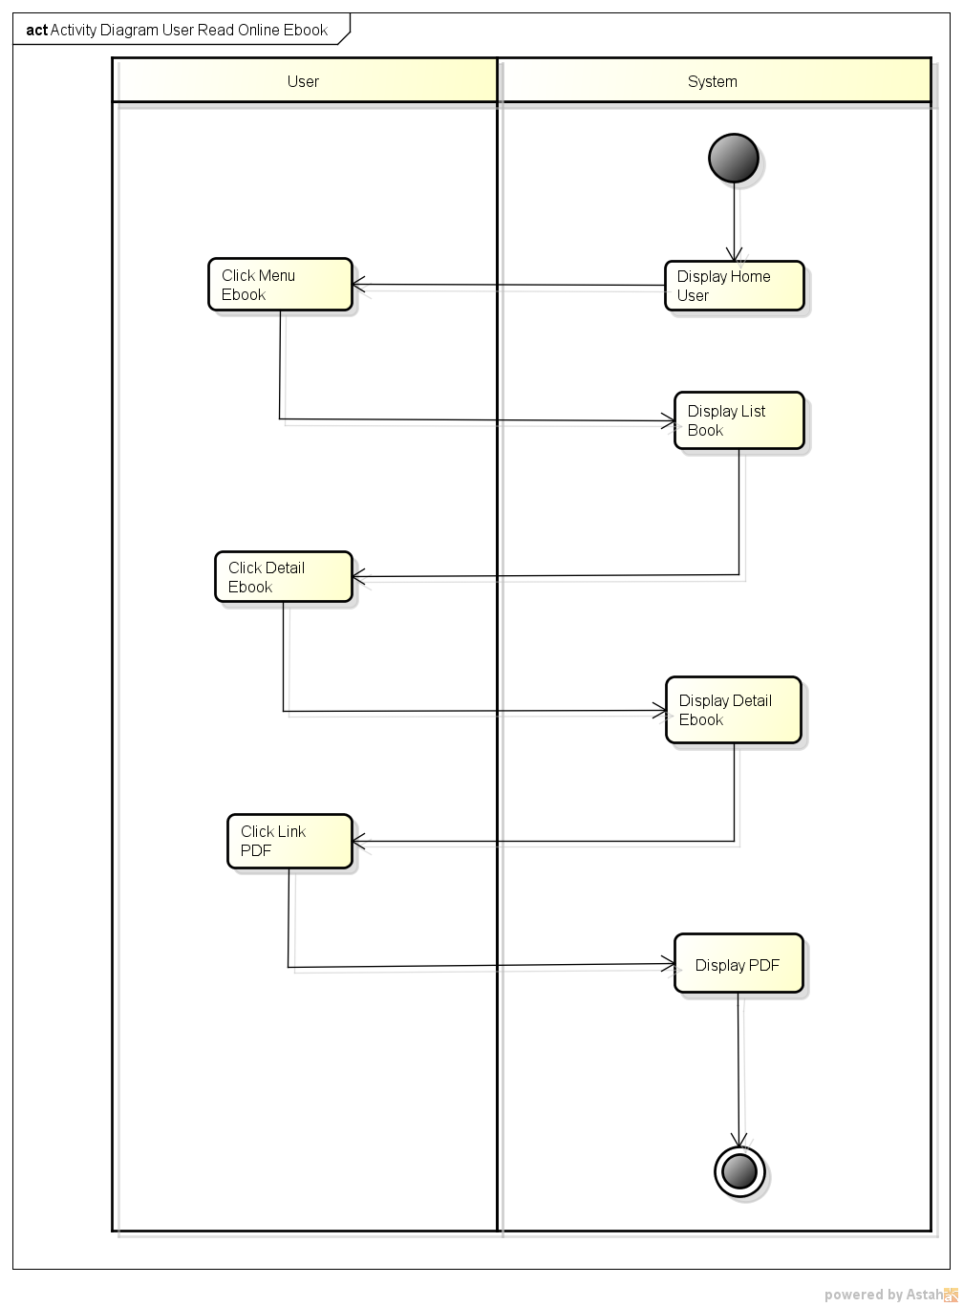

*Activity Diagram Read Online File*

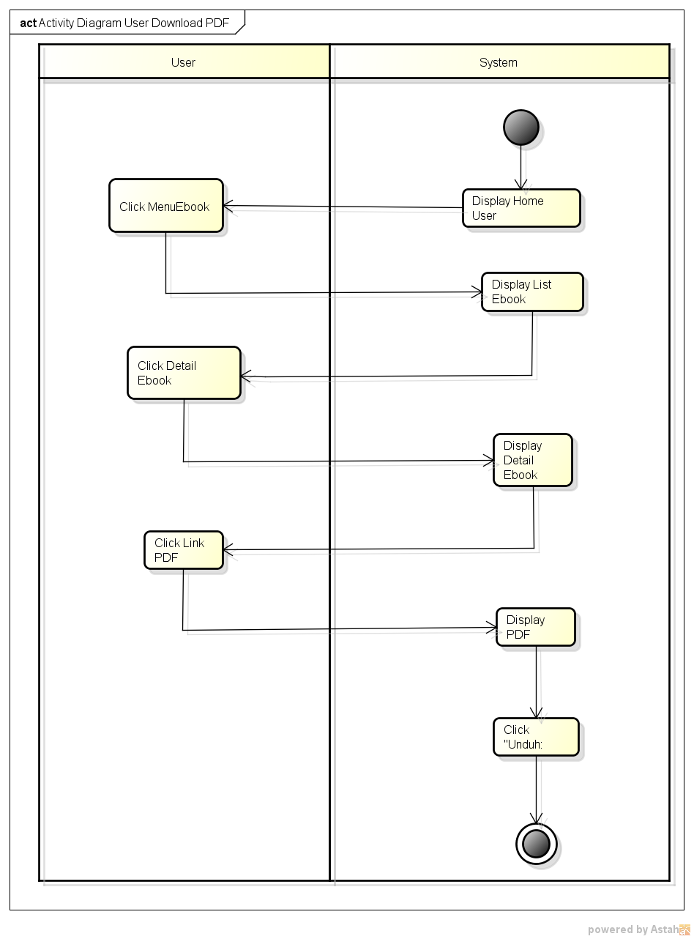

*Activity Diagram User Download File*

**SEQUENCE DIAGRAM FOR E-BOOKS PROG WEB BASED APPLICATION**

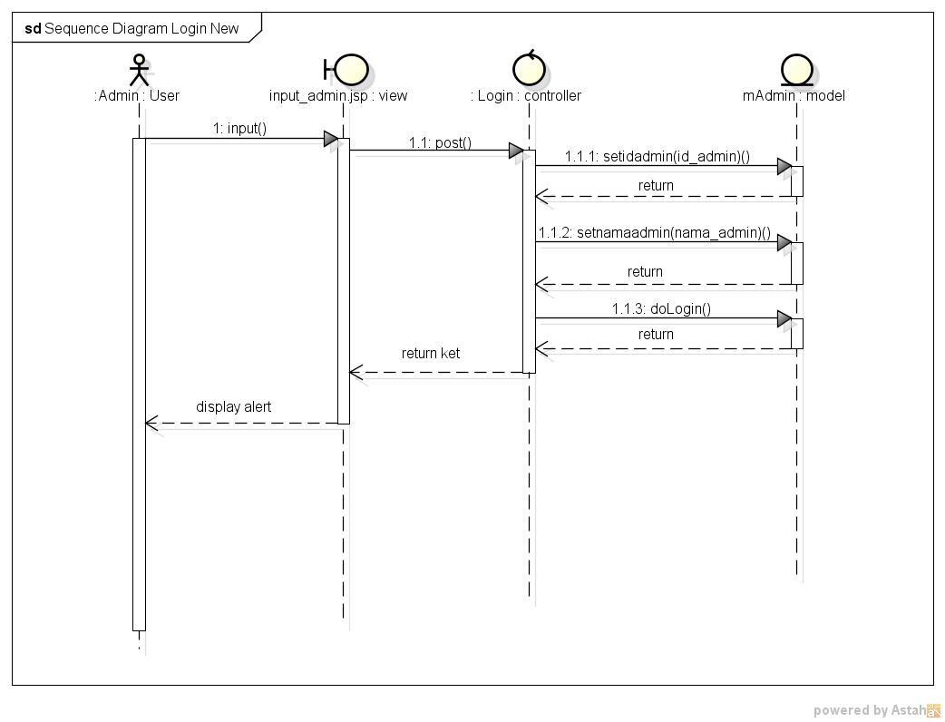

*Sequence Diagram Login*

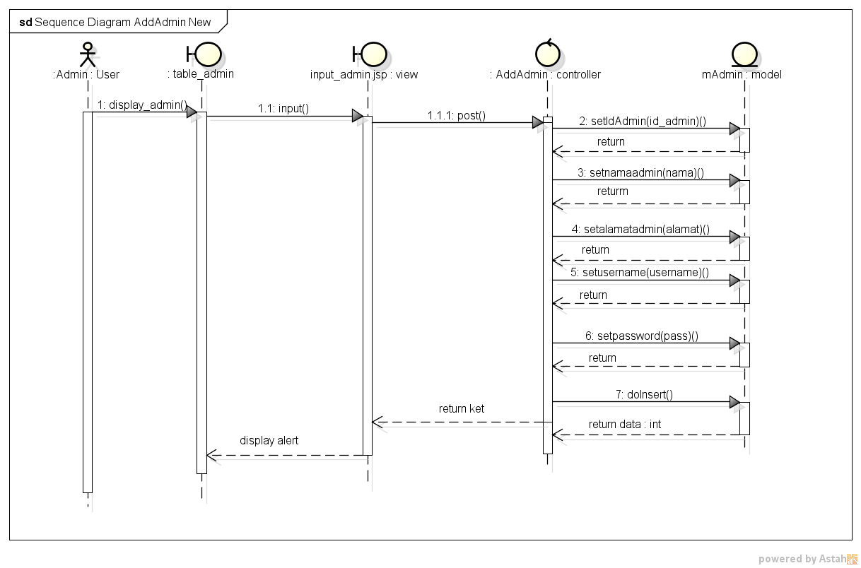

*Sequence Diagram AddAdmin*

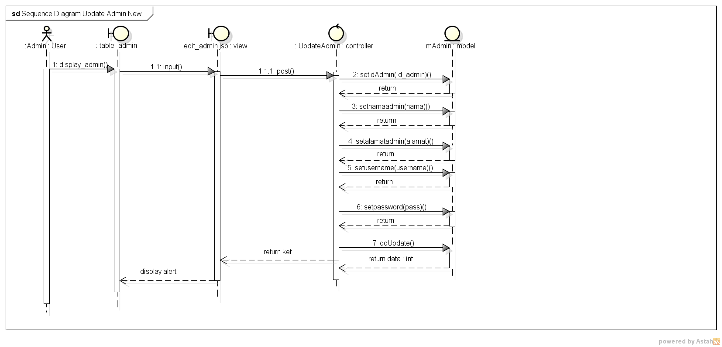

*Sequence Diagram Update Admin*

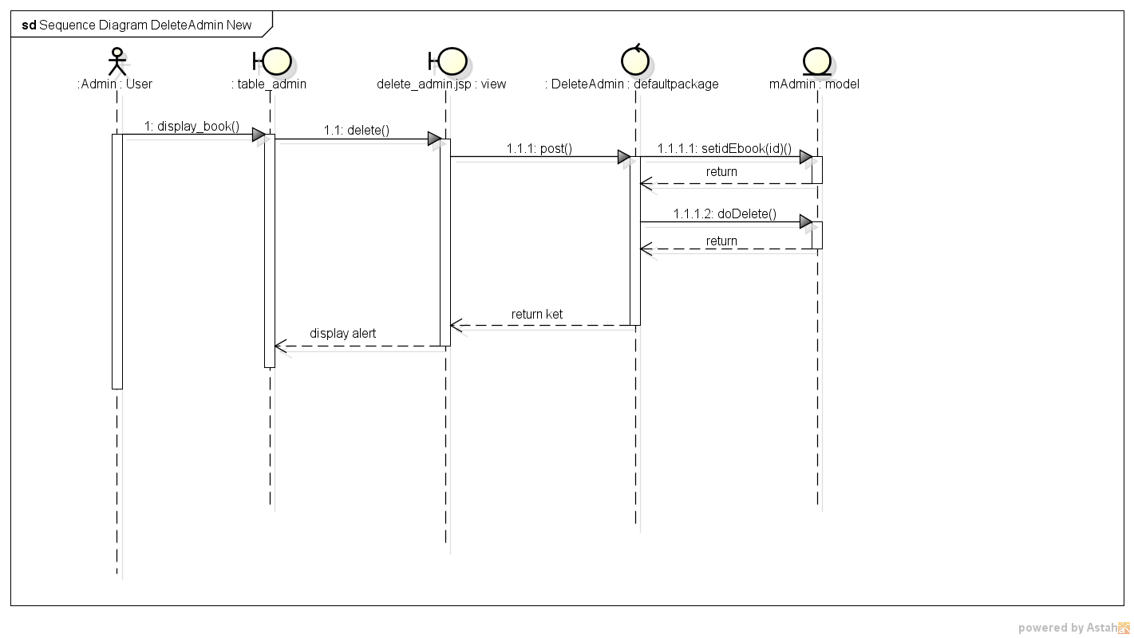

*Sequence Diagram Delete Admin*

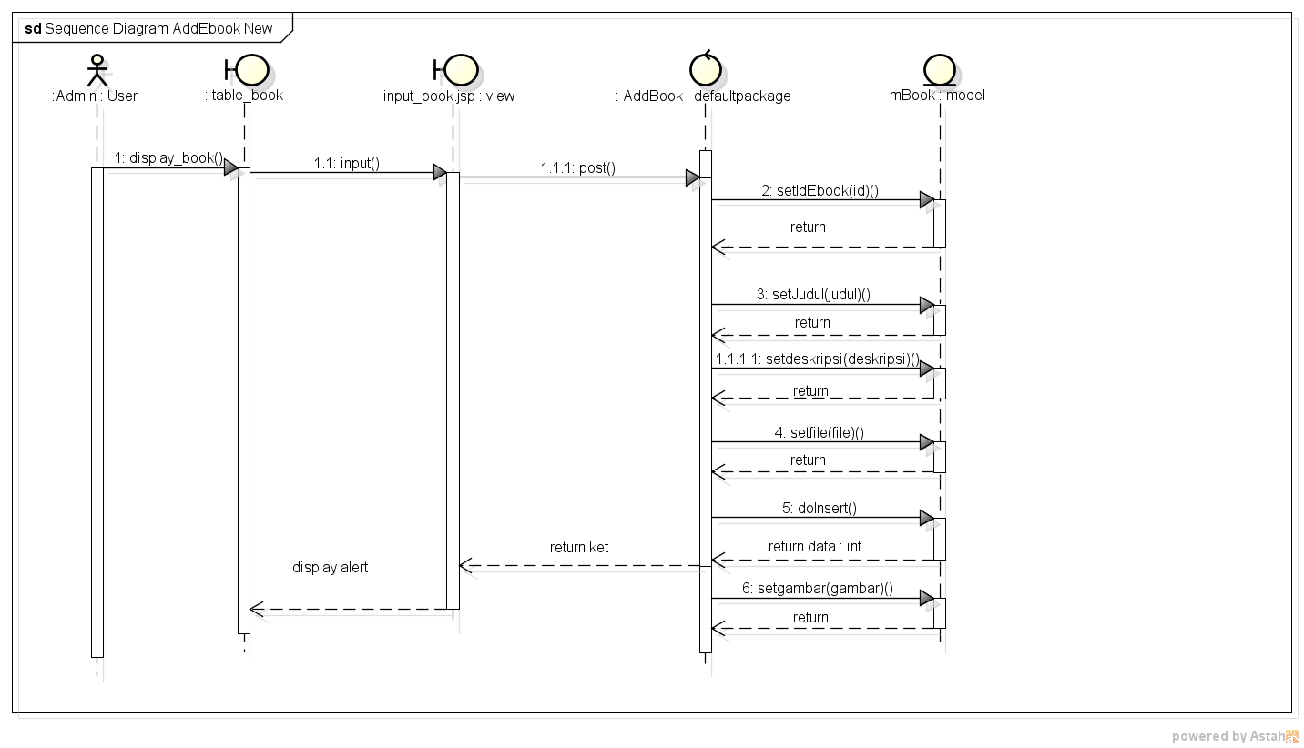

*Sequence Diagram Add Ebooks*

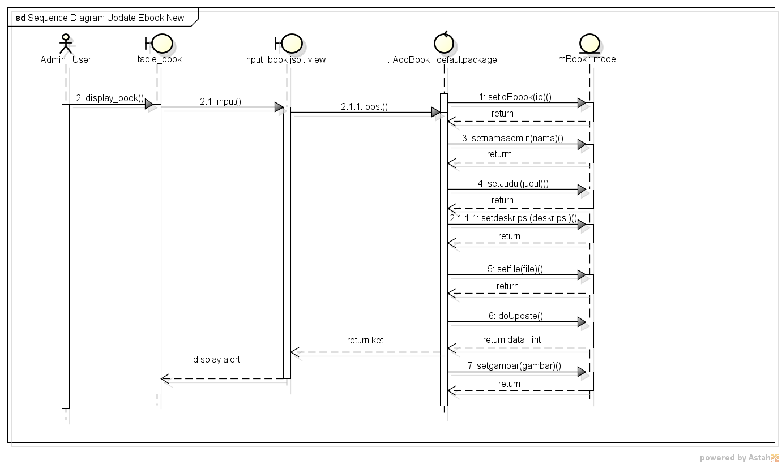

*Sequence Diagram Update Ebooks*

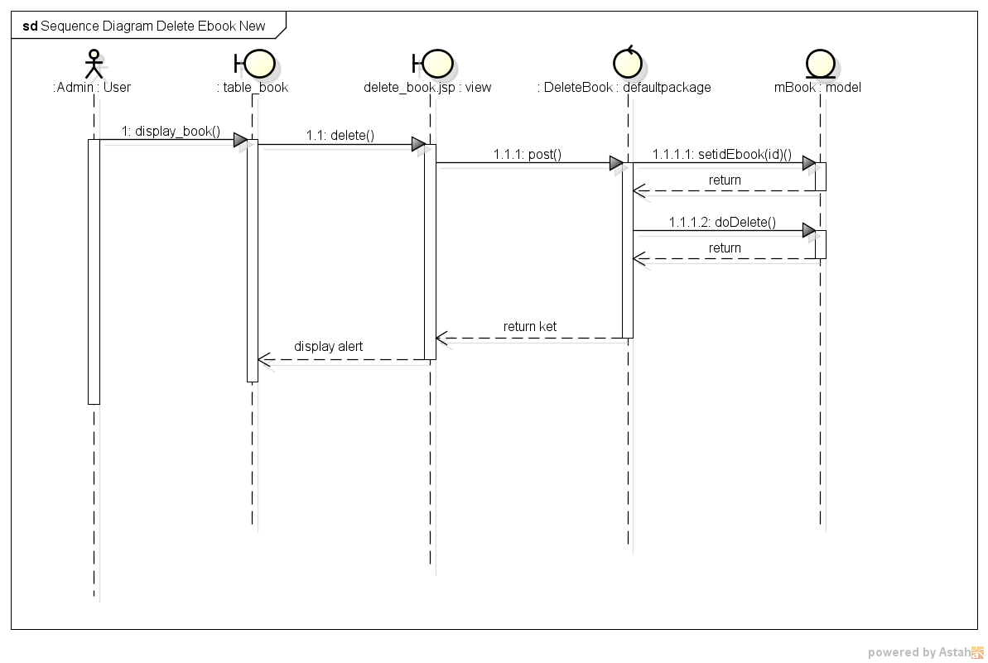

*Sequence Diagram Delete Ebooks*

**USE CASE DIAGRAM FOR E-BOOKS PROG WEB BASED APPLICATION**

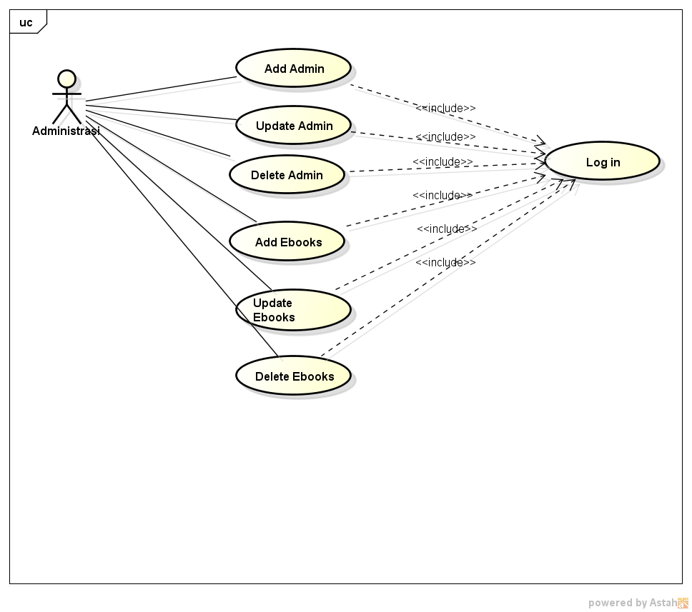

*Use Case Diagram Admin*

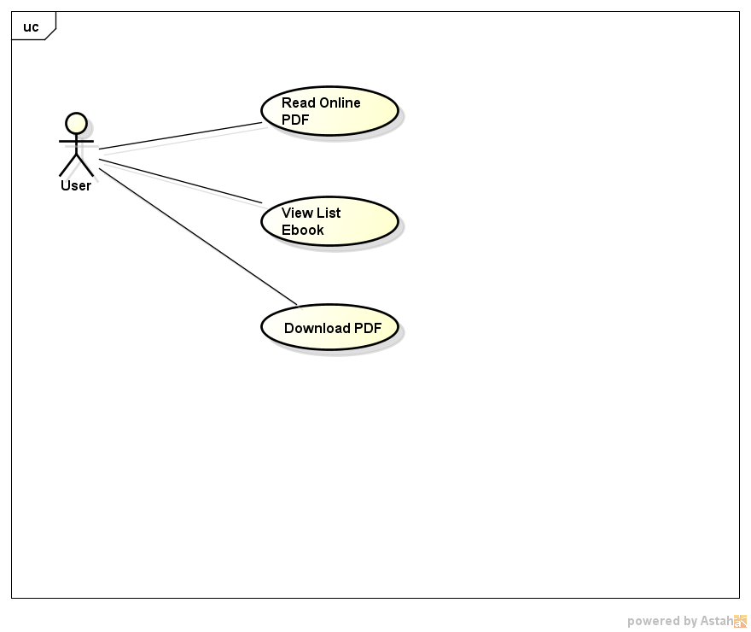

*Use case Diagram User*